Chapter 13, Solution 68.

In the ideal autotransformer of Fig. 13.130, calculate I₁, I₂, and I_{o}. Find the average power delivered to the load.
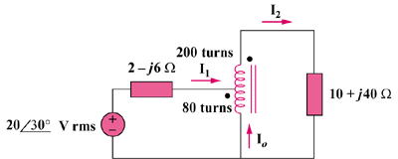

120∠45° V

Figure 13.130
For Prob. 13.68.

Solution

This is a step-up transformer.

10 + j40

120∠45°

+
−

+

v₂

−

+

v₁

−

2 – j6

N₂

N₁

I₂

I₁

For the primary circuit, 120∠45° = (2 – j6)I₁ + v₁ (1)

For the secondary circuit, v₂ = (10 + j40)I₂ (2)

At the autotransformer terminals,

v₁/v₂ = N₁/(N₁ + N₂) = 200/280 = 5/7,

thus v₂ = 7v₁/5 (3)

Also, I₁/I₂ = 7/5 or I₂ = 5I₁/7 (4)

Substituting (3) and (4) into (2), v₁ = (10 + j40)25I₁/49

Substituting that into (1) gives 120∠45° = (7.102 + j14.408)I₁

I₁ = 120∠45°/16.063∠63.76° = 7.4706∠–18.76° A

I₂ = 5I₁/7 = 5.3361∠–18.76° A

I_{o} = –I₁ + I₂ = [–(5/7) + 1]I₁ = 2I₁/7 = 2.1345∠–18.76° A

p = |I₂|²R = (5.3361)²(10) = 284.7 W.

